1. **Importance of NameNode:**

The NameNode is the centerpiece of an HDFS file system. It is also known as Master.

It keeps the directory tree of all files in the file system, and tracks where across the cluster the file data is kept. It does not store the data of these files itself.

The entire file system metadata is stored in memory on a single NameNode, and all metadata operations are processed on this single system.

Client applications talk to the NameNode whenever they wish to locate a file, or when they want to add, copy, move, delete a file. The NameNode responds the successful requests by returning a list of relevant [DataNode](https://wiki.apache.org/hadoop/DataNode) servers where the data lives.

When the NameNode goes down, the file system goes offline. There is an optional [SecondaryNameNode](https://wiki.apache.org/hadoop/SecondaryNameNode) that can be hosted on a separate machine. It only creates checkpoints of the namespace by merging the edits file into the fsimage file and does not provide any real redundancy.

1. **Basic HDFS Commands**

### ****1. Put Command****

The ‘put’ command feeds the data in to the HDFS.

Syntax:**hadoop dfs –put </source path> </destination path>**

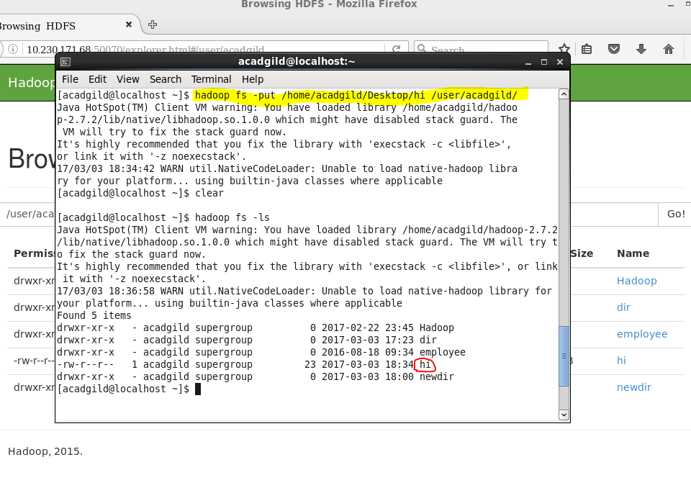

### ****2. List Command****

The ‘list’command displays all the available files inside a particular path.

Syntax:**hadoop dfs –ls </source path>**

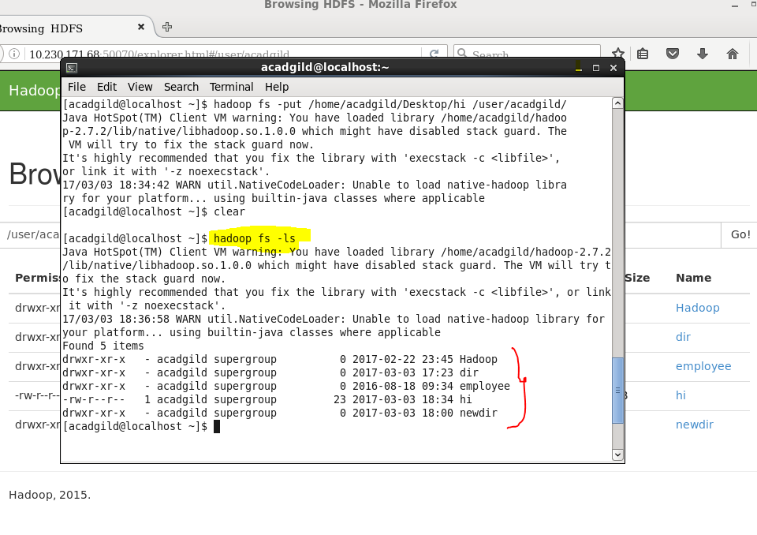

### ****3. Get Command****

The ‘get’ command copies the entire contents of the mentioned file to the local drive.

Syntax: **hadoop dfs –get </source path> </destination path>**

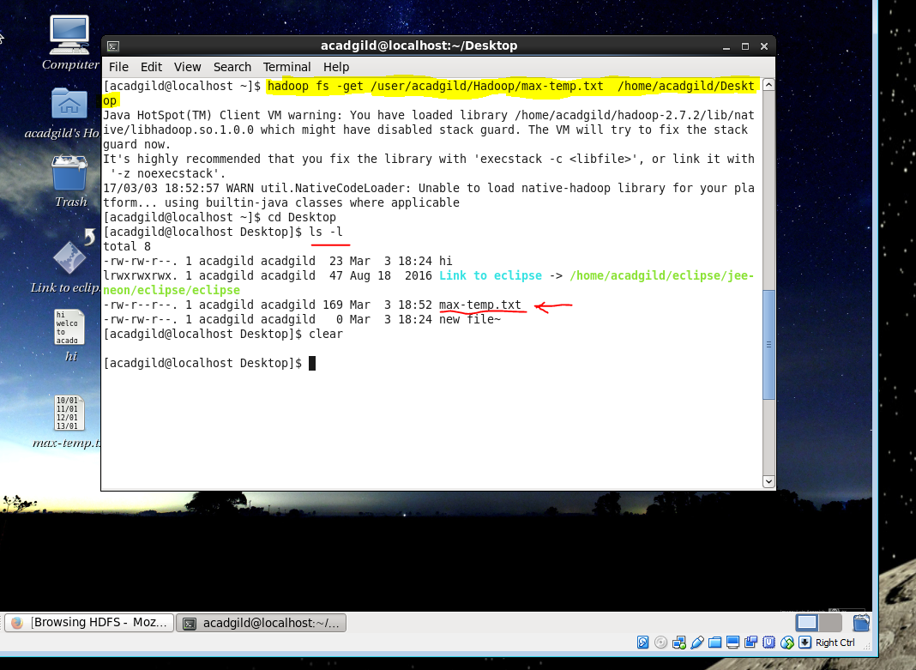

### ****4. Make Directory Command****

The ‘mkdir’ command creates a new directory in the specified location.

Syntax:**hadoop dfs –mkdir </source path>**

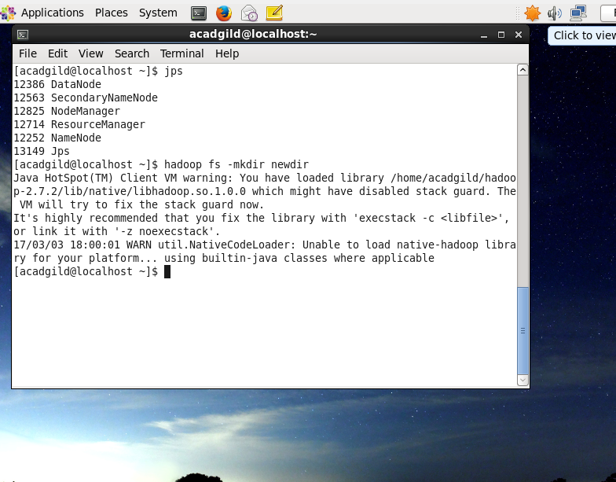

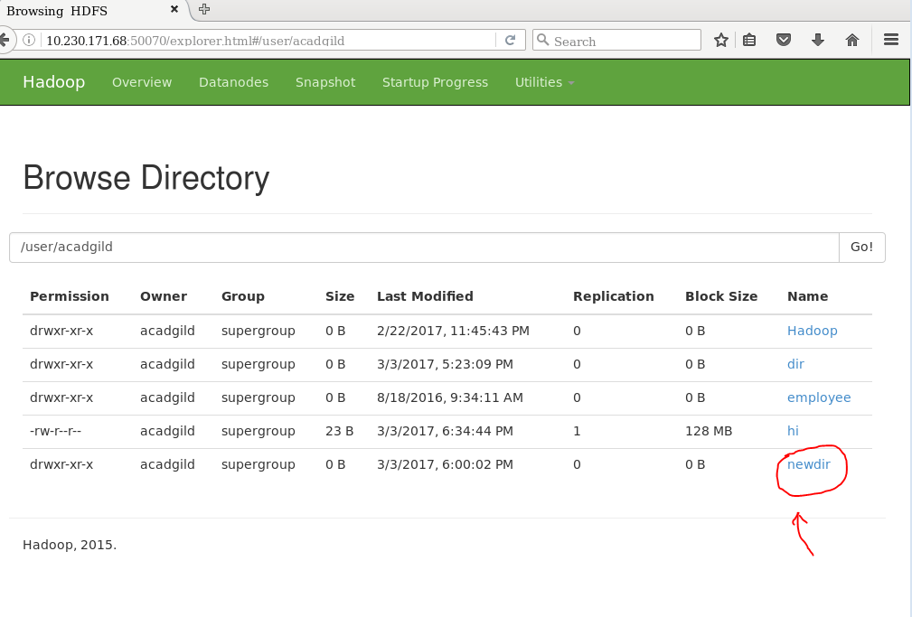

### ****5. View contents of particular file****

The ‘cat’ command is used to display all the contents of a file.

Syntax:**hadoop dfs –cat </path[filename]>**

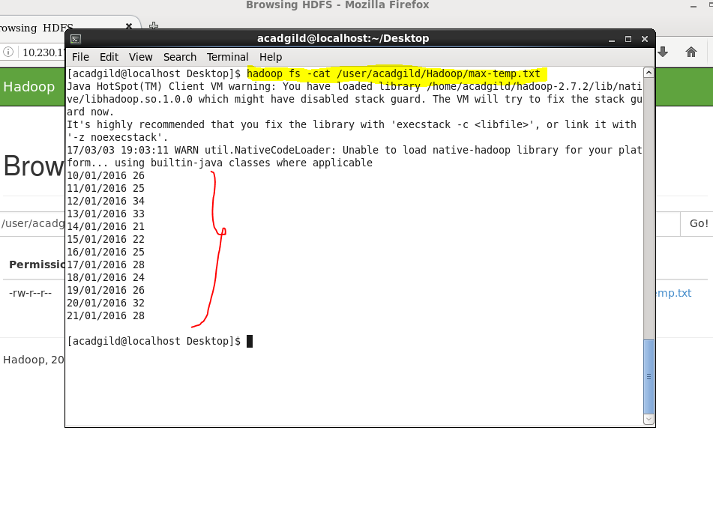

### ****6. Duplicating a Complete File inside the HDFS.****

The ‘copyfromlocal’ command will copy file from the local file system to the HDFS.

Syntax:**hadoop dfs –copyFromLocal </source path> </destination path>**

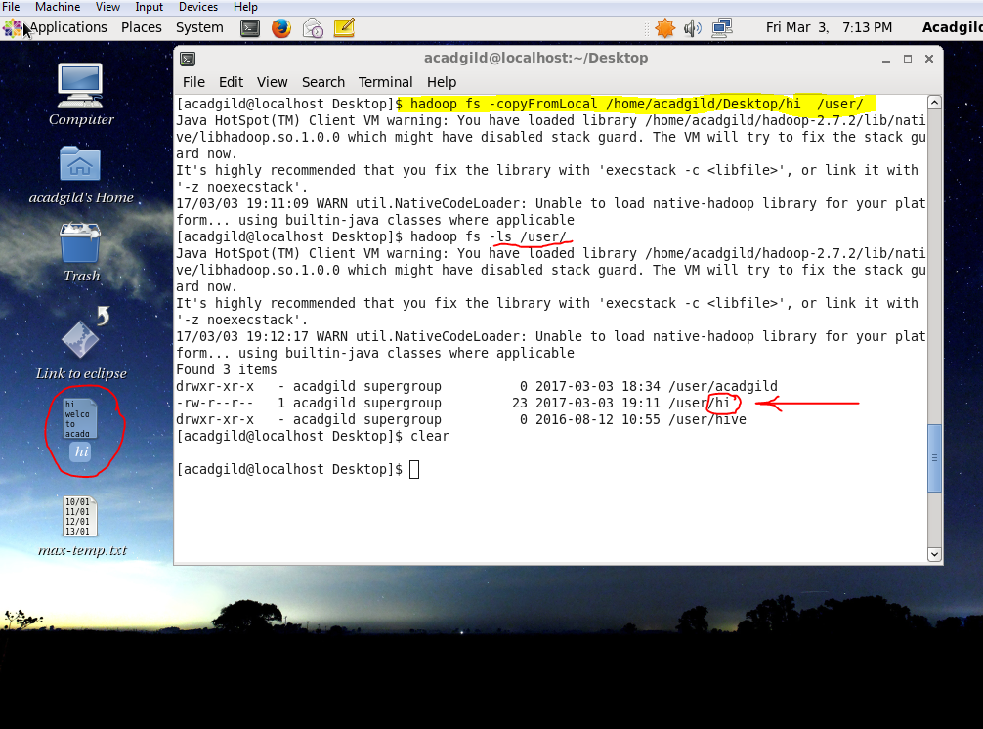

### ****7. Duplicating a File from HDFS to the Local File System.****

The ‘copytolocal’ command will copy files from the HDFS to the local file system.

Syntax: **hadoop dfs –copyToLocal </source path> </destination path>**

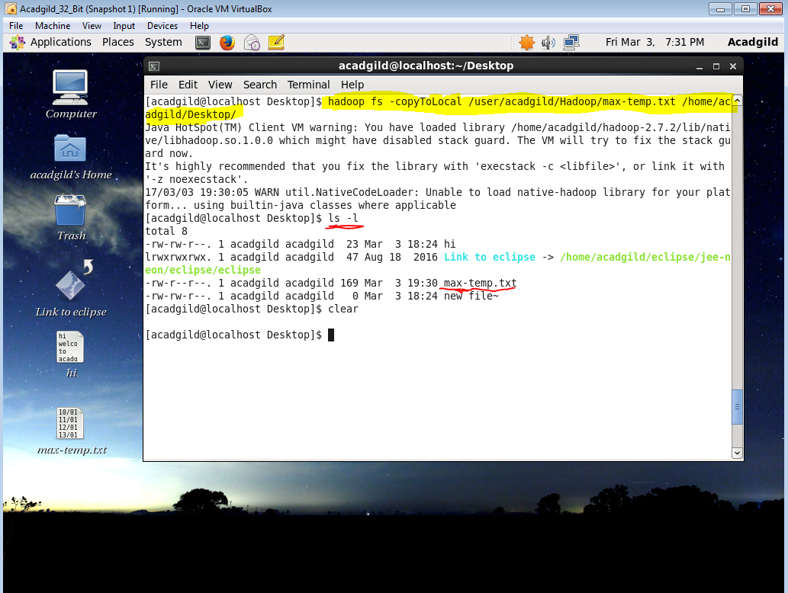

### ****8. Removing the File****

The command ‘rm’ will delete the file stored inside the HDFS.

Syntax: **hadoop dfs –rm </path[filename]>**

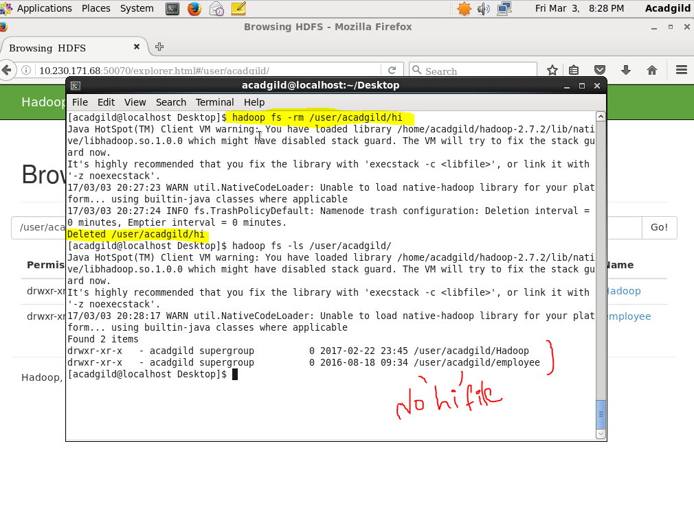

### ****9. Run a DFS Filesystem to Check Utility****

The command ‘fsck’ is used for checking the consistency of a file system  
Syntax: hadoop fsck </file path>

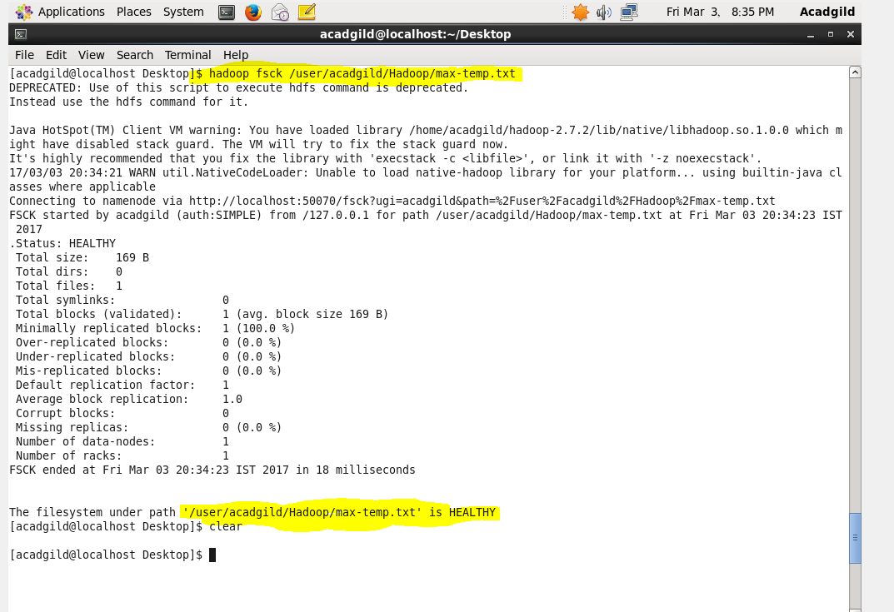

### ****10. Run a Cluster Balancing Utility****

The command ‘balancer’ will check for work load on nodes in cluster and balance it.  
Syntax: **hadoop balancer**

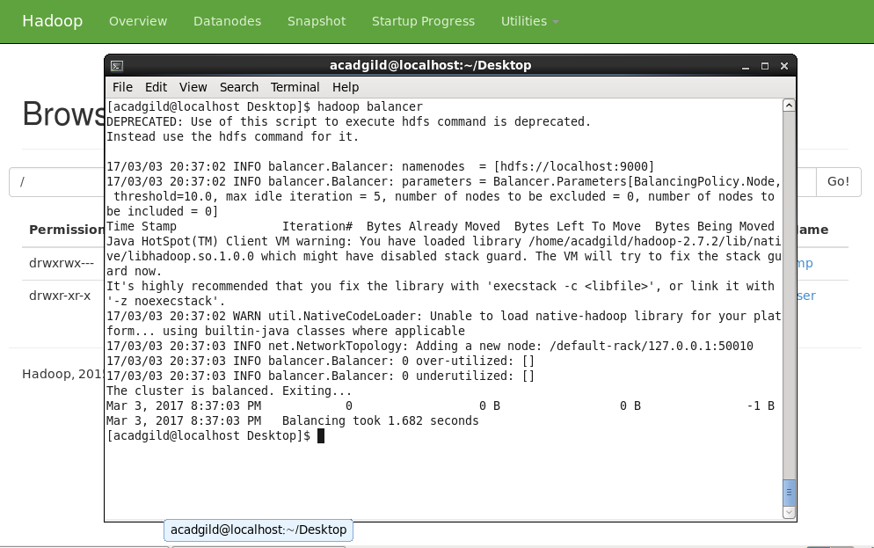

### ****11. Check Directory Space in HDFS****

The command will show the file size occupied by file inside cluster.

Syntax: **hadoop dfs -du -s -h </file path>**

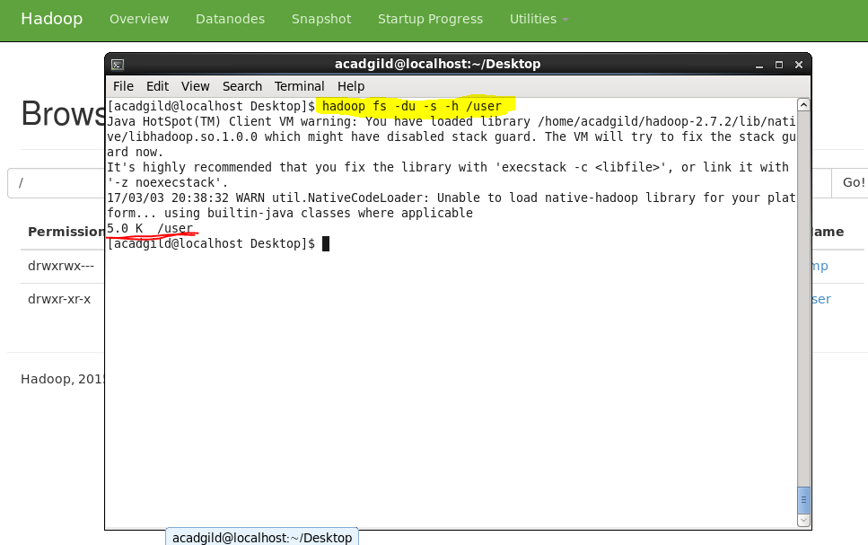

### 12. List all the Hadoop File System Shell Commands

The ‘fs’ command lists down all the shell commands of the Hadoop File System.  
Syntax: **hadoop fs [options]**

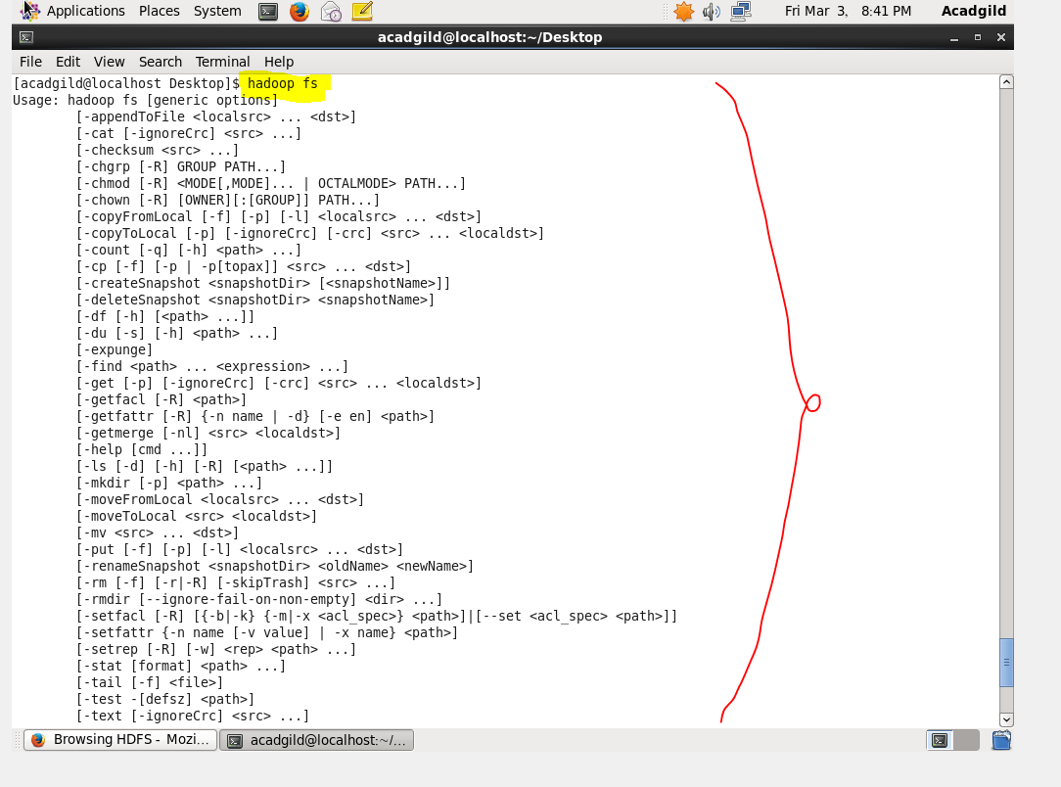

### ****13. Asking for Help****

The ‘help’ command is for asking for help or querying a particular question.

Command: **hadoop fs –help**

